Blocky Times

By:

Answer: VITRUVIUS

This puzzle uses three different encoding techniques. One is semaphores…

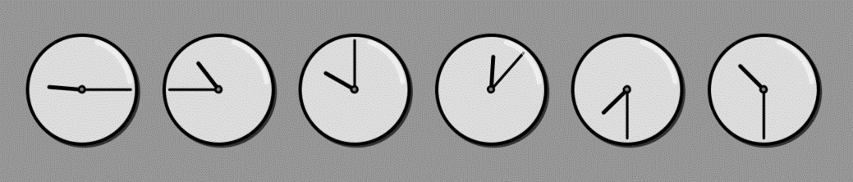

**R**

**O**

**T**

**#**

**1**

**3**

This spells out ROT13, which is another encoding scheme. Let’s hold onto that for now. The third encoding scheme is braille…

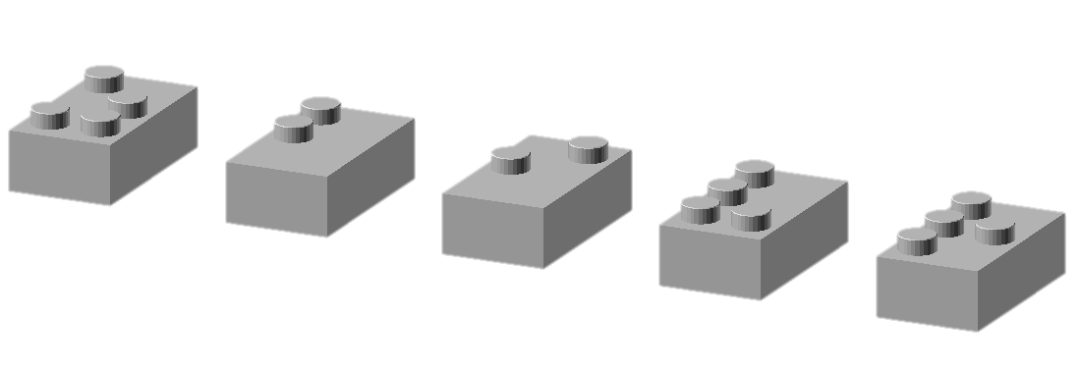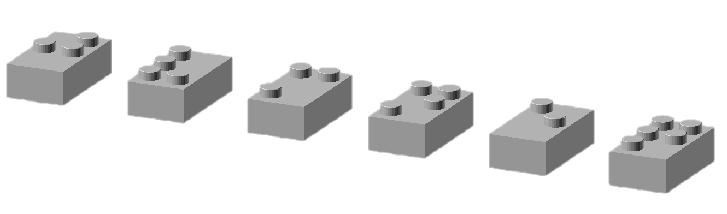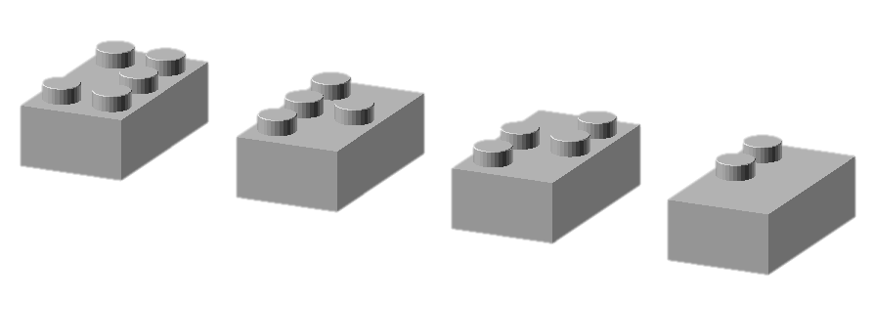

**Y**

**R**

**T**

**B**

**Z**

**B**

**I**

**V**

**R**

**J**

**V**

**M**

**N**

**E**

**Q**

Applying ROT13 to YRTB ZBIVR JVMNEQ produces LEGO MOVIE WIZARD. The Lego Movie has a Wizard character, a blind master builder called **Vitruvius**.